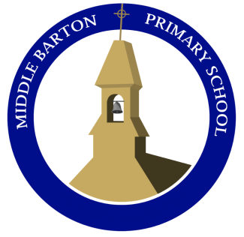**Middle Barton School**

**Newsletter**

**Friday 11th June 2021**

**National Thank a Teacher Day**

To coincide with *National Thank a Teacher Day,* 23 June 2021, Oxfordshire County Council is asking for messages of appreciation for teaching and support staff.

Last year’s touching comments showered praise and thanks on teachers and support staff during the challenging months of the Pandemic – and we want to hear more this year! During the past year staff have work tirelessly to provide lessons and resources, in many cases remotely, and this is a way to publicly to show huge appreciation for them.

We would be glad to receive short contributions (Twitter-length) from children, parents or guardians who wish to say thank you in any way they see fit – comments, poems, or other...

Please send to  [SchoolImprovementTeam@Oxfordshire.gov.uk](mailto:SchoolImprovementTeam@Oxfordshire.gov.uk) by **Friday 18 June**.

On *Thank a Teacher Day* a selection of the tributes will be shared on the Council website and on social media, using the hashtag **#ThankATeacher**

**Head’s News**

Firstly, I wanted to share some staffing updates with you. Miss Arthur has been lucky enough to secure a new role and so will be leaving at the end of the year. In the same breath, we have appointed Mr Smith, who has been training in Year 1, from September. We also welcome Zoe Webb to our kitchen team.

This leads me to classes next year. We can now confirm the teaching staff as the 'transfer window' is now closed.

* Reception / Year 1 = Mrs Merry
* Year 2 = Miss Reynolds
* Year 3/4 = Miss Sylvester
* Year 4/5 = Mr Smith
* Year 6 = Mrs Bryce

Teaching assistants have not been allocated to roles yet as there is the possibility for movement still.

The children in Year 4 will be told which class they are in as soon as we have clarified it.

There has been some updated guidance around isolation and testing. If you are isolating due to direct contact with a positive case, you are now strongly advised to take a PCR test on day 5 of isolation. This includes all children and babies. If you need further help, please just ask.

We are organising an end of year 'event' for all the children. Rather than risk taking them out, seeing as the lifting of restrictions is seeming less straightforward, we are arranging a variety of visits to school to mark the focus on the Arts next year. If you have any skills or connections in sculpture, mosaics, jewellery making, music or drama, please contact Rachel in the office.

Have a lovely weekend and try to stay cool!

**Art Club**

Starting next Thursday, 17th June, Miss Sylvester will be running an after-school Art club for years 2 and 3. This will be held in Maple classroom until 4.00pm.

Parents will be sent a link to sign up for the club – please complete by Wednesday 16th June to enable sufficient resources to be provided.

**Dojo points**

**Acorn – Sienna Chestnut - Alex W Sycamore – Billy/Archie H**

**Maple – Riley Willow – Dexter Oak - Afia**

**Caterpillars!**

The Acorns enjoyed guessing what had arrived in a box for them this week! The children were excited to see some tiny little caterpillars wriggling around in pots! We have placed them in a quiet area of the classroom and we will be observing them closely over the next few weeks.

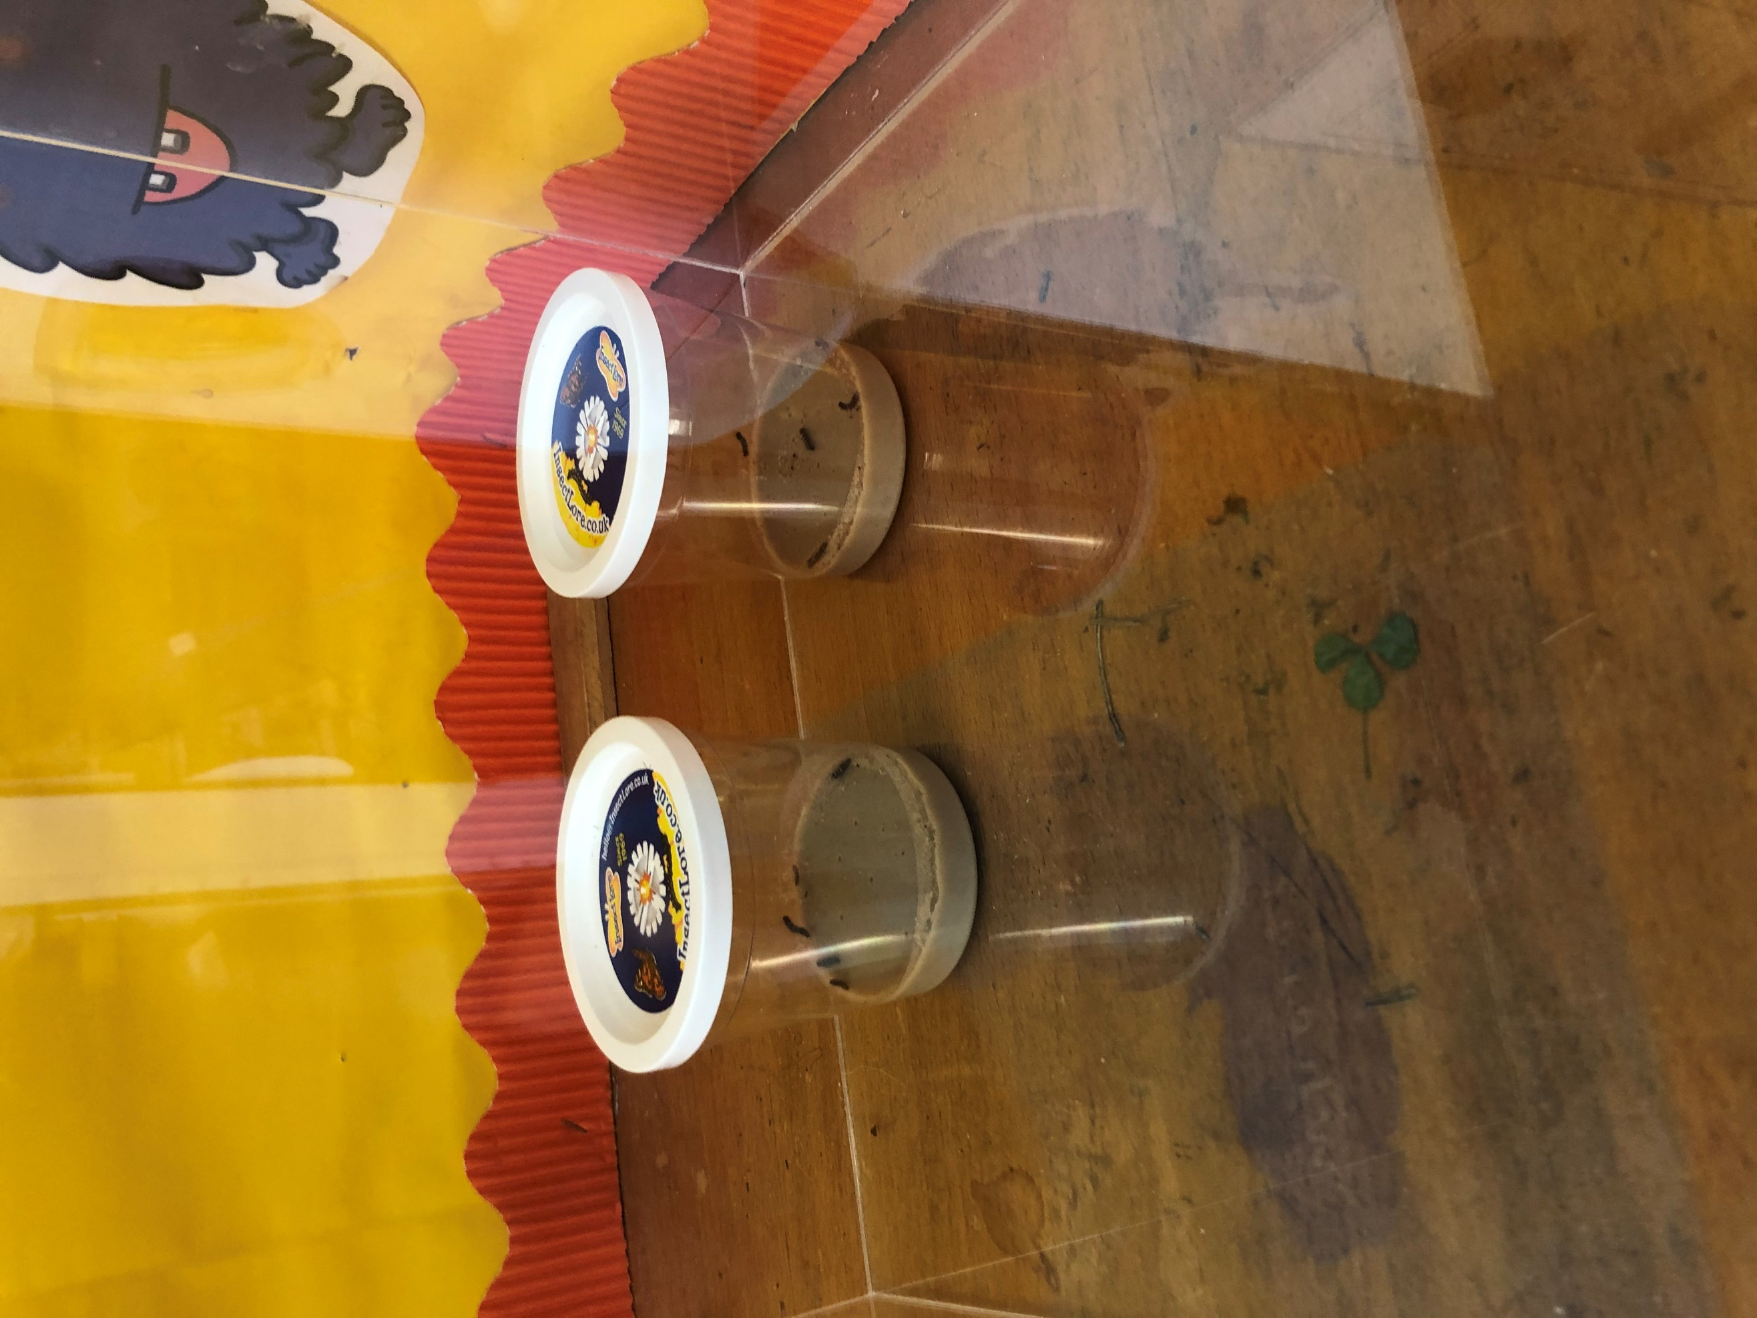

**Values leaves**

